### **Wayanad - Donation page**

### **Aim**

To design a visually appealing donation and payment portal interface for an initiative focused on supporting Wayanad using Figma.

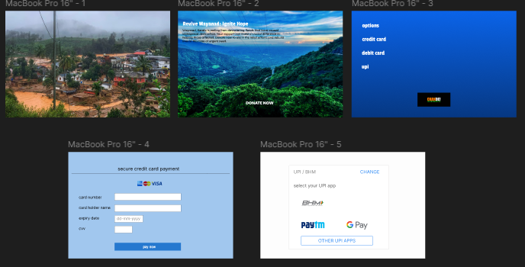

### **Procedure**

1. **Initial Layout and Content Planning**:
   * Planned a layout that includes a compelling visual section with an image of the location affected (Wayanad) to evoke emotions and encourage donations.
   * Added a clear "Donate Now" call-to-action to guide users to the donation process.
2. **Visual and Typography Elements**:
   * Used high-resolution, meaningful images that depict both the need and the beauty of the region.
   * Selected fonts that are easy to read and maintain a professional look throughout the design.
3. **Creating Interactive Elements**:
   * Designed buttons and interactive fields for choosing payment options such as credit card, debit card, and UPI.
   * Used Figma’s interactive components feature to create hover states and clickable elements for a more realistic prototype experience.
4. **Color Scheme and Branding**:
   * Used a combination of soothing blues and whites to create a trustworthy and welcoming feel.
   * Ensured the colors used for buttons and text stand out, maintaining high contrast for better visibility.
5. **Form Design and Usability**:
   * Created a clean, user-friendly credit card input form with labeled fields for card details.
   * Added a section for selecting UPI apps, featuring popular options with their recognizable logos for easy navigation.

### **Result**

The final design is a well-organized, visually appealing donation portal that ensures clarity and ease of use. It effectively guides users through the donation process, encouraging support for the Wayanad initiative with its intuitive layout and design elements. The interface aligns with modern design principles and offers a seamless donation experience.